Project Design Phase-II
Technology Stack (Architecture & Stack)
Date | 14 October 2026
Team ID
Project Name | Employee Raise Issue – Record Producer & Service Portal Integration Guide (ServiceNow)
Maximum Marks | 4 Marks

Technical Architecture:
The architecture below shows the user, the ServiceNow cloud (portal, widgets, record producer, platform logic and database) and the external and admin interfaces. Details are in Table-1 and Table-2.
Example: Employee issue reporting through a ServiceNow Service Portal
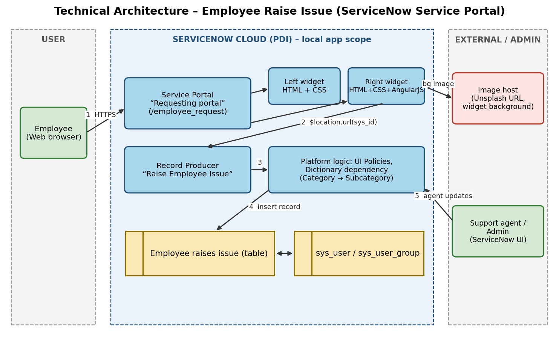

Table-1 : Components & Technologies:
S.No | Component | Description | Technology
1 | User Interface | Employee uses the Requesting portal (/employee_request) in a web browser | HTML, CSS, Bootstrap and AngularJS (ServiceNow Service Portal), Employee Center Coral theme
2 | Application Logic-1 | Left widget “Commercial widget” shows service highlights with floating text and animated gradient | Service Portal widget: HTML template and CSS animations
3 | Application Logic-2 | Right widget “Link redirect” shows the Raise Ticket card and redirects to the record producer using its sys_id | AngularJS client controller ($location), HTML and CSS
4 | Application Logic-3 | Record Producer “Raise Employee Issue” creates the record; UI policies and dictionary dependency validate input | ServiceNow Service Catalog, UI Policies, Dictionary configuration
5 | Database | Custom table “Employee raises issue” with fields (Number, Requester, Category, Subcategory, Short description, State, Priority, Assignment group) | ServiceNow platform relational database
6 | Cloud Database | Database service hosted with the ServiceNow instance | ServiceNow cloud (Personal Developer Instance)
7 | File Storage | Portal logo and catalog item picture stored as attachments | ServiceNow attachment storage
8 | External API-1 | Widget background image loaded from a public image URL | Unsplash image URL (no API key needed)
9 | External API-2 | Not used in this project | N/A
10 | Machine Learning Model | Not used in this project | N/A
11 | Infrastructure (Server / Cloud) | Application is deployed on the ServiceNow cloud instance; no local server is needed | Local Server Configuration: browser only. Cloud Server Configuration: ServiceNow Personal Developer Instance

Table-2: Application Characteristics:
S.No | Characteristics | Description | Technology
1 | Open-Source Frameworks | Front end of Service Portal widgets uses open-source UI frameworks | AngularJS, Bootstrap
2 | Security Implementations | Login-based access, role-based access control and ACLs, HTTPS, reference fields instead of free text for users and groups | ServiceNow authentication, roles and ACLs, TLS/HTTPS
3 | Scalable Architecture | Multi-tier design (browser, application, database); configuration-based changes allow adding fields, widgets and workflows | ServiceNow platform (3-tier)
4 | Availability | Hosted and managed on the ServiceNow cloud; development instances may hibernate after inactivity | ServiceNow cloud hosting
5 | Performance | Lightweight widgets, CSS transform animations, single-record insert per submission, platform caching | CSS3, Service Portal widget caching

References:
https://c4model.com/
https://www.servicenow.com/docs
https://developer.servicenow.com/

